**Mentor Community**

Our mentor community strongly believes in the power of sharing!  
We collaborate with professionals from great companies to guide you on this exciting journey.



and many more...

[Request a Callback](https://forms.ccbp.in/public/form/talk-to-career-expert)

## Work on real-world projects  and gain industry-required skills

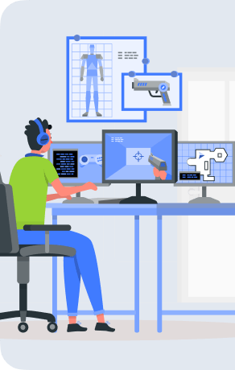

**Game like Counter Strike (3D)**

Build 3D games where two teams compete in game modes to complete objectives, such as defuse a bomb or rescuing, etc.



**Face recognition with AI/ML**

Builda face recognition software using CNNs that automatically detects the important features without any human supervision.

**Board games bots**

 Create unbeatable bots using ML for board games like chess,checkers,etc using adversarial search based algorithms

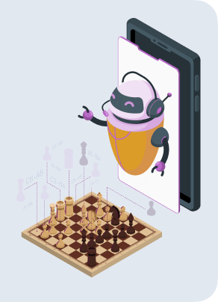

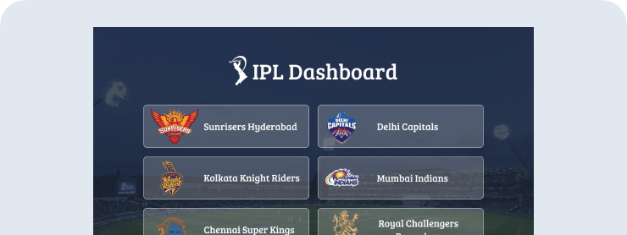

**IPL Dashboard App**

Implementing IPL Dashboard app where users can list of ipl team, individual team details and respective team matches info



**Smart Door Light**

Build a door activated lighting system which will turn on the light as soon as you open the door



**Unemployment Trends due to Covid**

Are young generations most affected by Covid 19? With Data Science, develop hypotheses to statistically analyze the unemployment trends

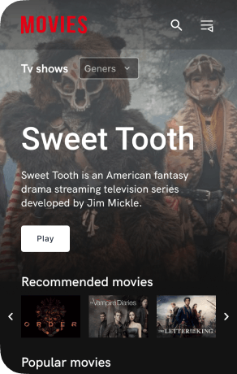

**Movie recommendation system with AI/ML**

Build a movie recommendation system and compete in a competition similar to the famous ‘Netflix Prize’.

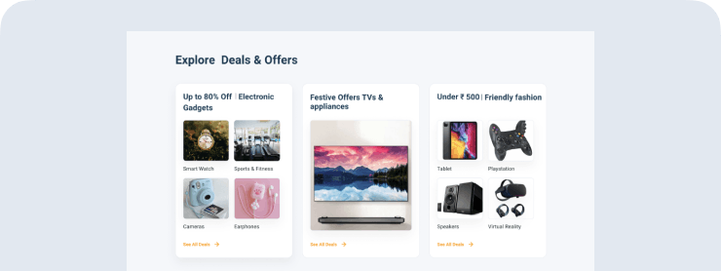

**ECommerce App**

Implementing Nxt Trendz Ecommerce application like Amazon where users can login and can see products with search, filters, etc..

**Cyber Warrior  
Level 1**

Band up with 5 peers to attack & compromise targets of different difficulty levels to earn the Cyber Warrior Level 1 Badge.

Providing online education for

## Learners across 170+ countries

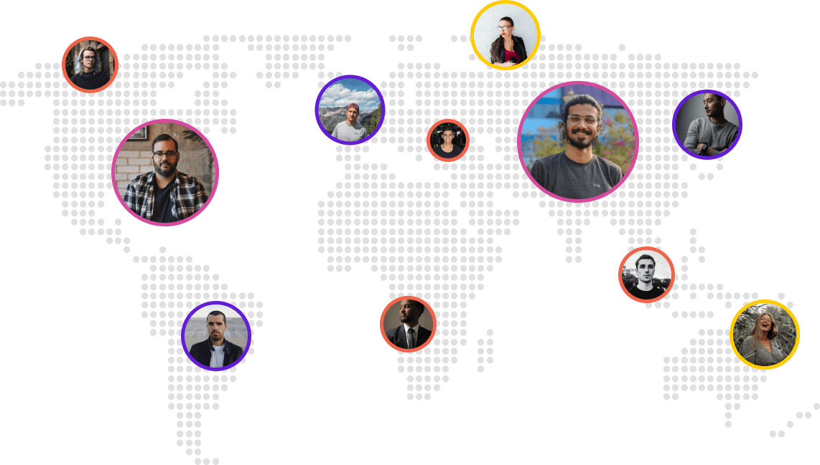

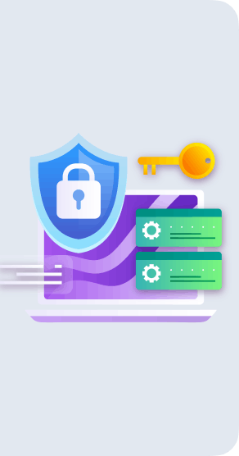

[Request Callback](https://forms.ccbp.in/public/form/talk-to-career-expert)

Get IRC  
Get supported till you achieve a  
₹12 LPA Job

With our placement support, get placed at Top MNCs and Fast Growing Startups

We'll help you with

Interview Preparation



Aptitude



Soft skills



Resume Building



Mock Interviews

**Direct access to Interviews with our Hiring Partners**

**OUR ACADEMIC COLLABORATIONS**

Stanford Graduate School of Business Executive Education

University of Texas - McCombs



Northwestern University

















SRM Institute of Science and Technology (SRMIST)

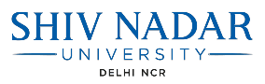



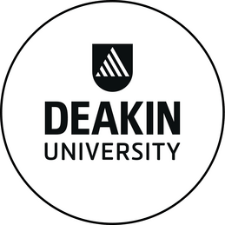



Stanford Graduate School of Business Executive Education

University of Texas - McCombs



Northwestern University

















SRM Institute of Science and Technology (SRMIST)









### World-class professionals with in-demand skills in top domains

#### **Data**

Data Science

Machine Learning

Artificial Intelligence

Big Data

Deep Learning

Data Visualisation

#### **Technology**

Front-end Development

Cloud Computing

Dev Ops

Cyber Security

#### **Business**

Business Analytics

Digital Marketing

Management

### Career Prep

Learn from leading academicians in the field of data science and business analytics and several experienced industry practitioners from top organizations.

#### 4.7/5

Avg Mentorship Rating

#### 3500+

Guidance sessions done

[**Get Counseling Call**](javascript:void(0))

### 1 : 1 Career mentoring

* 1:1 LIVE online sessions with experienced industry professionals

* Expert mentors guide you on the career path that’s right for you

* Suggestions on setting your short term and long term career goals

* Mentors from various domains help you gain valuable industry insights

### CV/LinkedIn Review

* Feedback from experts to make your resume and LinkedIn profiles stand out from the crowd

* Personalized and detailed suggestions to improve the content and format of your CV

* Tips on customizing your resume for the job profile you are applying to

### Interview Preparation Session

* 1:1 mock interviews with industry experts to help you land your dream job

* Guidance from our alumni currently in roles you aspire for

* Develop industry context with case studies and learn answers to common technical and HR questions

`````````````